Online Angels

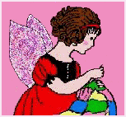

Loveghan Packages sent as of December 2003
1,212

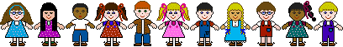

Warm Items for Children

We are collecting hats, scarves, earmuffs, and gloves to keep children warm this winter.



Please check out our auctions. They support our FedEx label program. Great items and great prices!
http://scripts.cgispy.com/auctions/

We now only accept PayPal, Money Orders and cash for payment of auction items. To use PayPal use this link
angels_auctions@earthlink.net



We need any color, any size 6-inch squares, and 4-inch squares. If yours are a different size, that is ok, we keep all sizes and when we have enough we sew them into loveghans and send them as well. We need health & beauty items, crosses, angels, toys, stuffed toys, clothes, slippers, yarn, and books. Anything you can think of to add to the boxes to uplift the recipients.

We send boxes to shelters so we need household items, clothes, health & beauty items, shoes, and things that they would be useful to them.

We send boxes to Veterans so we need health & beauty items, stationary, pens, pencils, stamps, puzzle books, slippers, and things that would be useful to them.

We send boxes to Children's hospitals so we need baby clothes, diapers, bibs, booties, hats, sweaters, blankets, powders, lotions, burial gowns, toys, stuffed toys, children's books, slippers, and things that would be useful to them.

We collect canceled stamps to give to local churches to purchase bibles for all over the world.

We collect soda tabs to give to local schools to give to the Ronald McDonald Houses to help families in their time of need.

We collect Christmas ornaments to add to boxes and to take to Nursing Homes to help brighten their Christmas.

If you have any questions or would like to donate items, please email me for more info or visit our website at:
http://www.online-angels.org
Or you can email me at:
onlineangels@earthlink.net

Thank you,
Mary Reinhart
Founder Online Angels



Important Changes

Due to the monthly contests running from the 1st through the 30th or 31st and the teams running from the 10-11th I am getting the contest counts mixed up.

So, to make it fair and not have any mistakes on my part with the winners, starting Jan the teams will run from the 1st-30th or 31st of each month.

Please sign up for teams now. We will have 5 to a team and as many teams as people sign up.

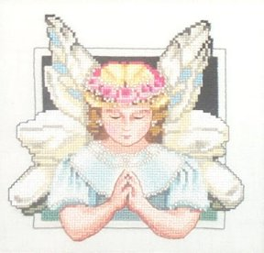

Calling All Postage Fairies

We are in need of Postage Fairies. If you do not craft and would like to help the Online Angels, you can, by being a postage fairy! A postage fairy sends monetary donations to help others use our FedEx package return program for their donations who otherwise would be unable financially. Every cent counts toward our piggy bank to pay our bills. If you would like to be a postage fairy, please email me for details.

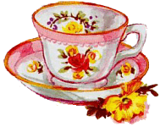

Sip and Ponder

"No one is useless in the world who lightens the burden for anyone else."
----Charles Dickens
Submitted by Teresa B. (Reesa)



Thank You Angels
A great big thank you to all of my Online Angels for making 2003 a wonderful year of blessings for many!

I am so honored and proud to head up this wonderful Organization that has been blessed and has grown and continues to grow by leaps and bounds.

May 2004 bring us many new opportunities to help more people, and bless them with the love that only Online Angels can spread through one Loveghan box at a time. And May God bless each and every one of you and yours with a happy, healthy, and blessed New Year!

Mary



Recipes

Zesty Caribbean Chicken Breast
6 Servings
1/4 cup CRISCO Oil
1 teaspoon grated lemon peel
1/4 cup lemon juice
1 tablespoon paprika
1 tablespoon honey
1 teaspoon ginger
1 teaspoon garlic salt
1 teaspoon oregano
1/3 teaspoon hot pepper sauce (optional)
6 boneless, skinless chicken breast halves (about 1-1/2lbs)
Combine oil and all the ingredients in a shallow baking dish. Stir well.
Add the boneless, skinless chicken breast halves. Turn to coat. Refrigerate 2 to 4 hours turning occasionally. Prepare grill or heat broiler.
Remove chicken from lemon juice mixture. Discard juice mixture. Grill or broil 3 to 5 minutes per side or until chicken is no longer pink in
center.



January Contest
Deadline is Jan 31

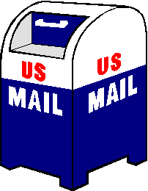

Please remember, all items are to be sent to Mary at the following address:

Online Angels
C/O Mary Reinhart
36 Pine Drive
Pottsville, PA 17901

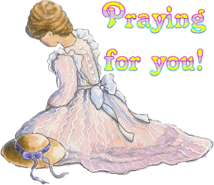

Penny Bubb
Sharon, Amy & family
Jessica Reinhart
Sandy Grimes

All prayer requests should be emailed to Mary or Cyndi P. They will be listed in the next months newsletter.

Would you like to announce a birth, wedding, engagement, bereavement? Anything you’d like to share with the group, send an email to Mary or Cyndi P and it will go in the following months announcements.


A very warm and loving
welcome to our newest members:

Ashley DeMazza
Alicia Wrona
Tim
Linda
Trisha Dunlap
Gloria Canfield
Theresa
Carol

Any contributions you would like to be considered for the newsletter can be emailed to Mary or Cyndi P. Cyndi’s email addy is clpeters@bellsouth.net



We need lots of squares for our Loveghans! Knitted or crocheted in 6-inch or 7-inch any design. If you have some lying around that are a different size, send them on also. All squares received will be put to use in a Loveghan.

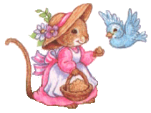

Jan Categories
Deadline Jan. 31

Squares
Health & beauty items
Baby items
Inspirational items
Chemo hats
Hats/ear warmers/gloves/socks for Troops



Team 1
Vicki Knott
Roxann Geishler
Vera Fite
Rena Martinez
Theresa Dunlap

Team 2
Tracye Stith
Diana Bidwell
Roberta Silva
Kay Batt
Linda Brownyard

Team 3
Karen Batt
Nancy Lankford
Jeanette Brimhall
Sandy Grimes
Bev Qualheim

Team 4
Ashley DeMazza
Linda Puhala
Chris Powers
Teresa Brandt
Barb Stadlberger

Team 5
Penny Bubb
Stacey Wilcox
Alicia Wrona
Linda Hauser
Gloria Canfield

Team 6
Jean Schimmelman
Ann Ryan
Dot Ketner
Emma Wood
Ruth Smith

Team 7
Lucy Slaght
Linda Garland
Judy Singly
Carol Burdick
Robin Grose
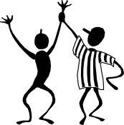
New Point System

Squares - 3 pts.
Crosses -1 pt.
Angels - 1 pt.
Insp. Items - 1 pt.
Chemo hats -1 pt.
Baby items - 1 pt.
Children's items - 1 pt.
Stationary items - 1 pt.
All books - 1 pt.
Slippers - 2 pts.
Hats/gloves/scarves - 1 pt.
Items for Troops/Veterans- 1 pt.
Wheel chair totes/laundry bags - 1 pt.
Health & beauty items - 2 pts.
Tabs - 1 pt.
Canceled stamps - 1pt.
Yarn - 5 pts.
Special project items - 5pts.
Afghans/Laprobes complete - 5 pts.
Quilts - 5 pts.



Monthly Yarn Winners

November winner-Mary Burns December winner-Chris Powers

I will do the drawing for yarn once a month.

To get your name in the drawing all you have to do is send in ANY donation from the first of each month to the last day of each month.

At the end of the month EVERYONE that sent in ANY donation will be entered into the drawing and my children will pick the winner this way I won't know till the name is drawn.

Items Needed For Various Projects

Pine Ridge Reservation
Sweaters
Socks
Mittens
Gloves

Ear Warmers
Scarves
Baby Clothes
Toys
Children’s Books
Health and Beauty items
Campbell’s Labels
Education Boxtops
Christmas Gifts for children and adults

California Fire Victims
Work gloves
Goggles
White masks
Toothbrushes
Toothpaste
Combs
Brushes
Deodorant
Soap

Children’s Hospitals
Isolette Covers 36” X 36” – bright colors
Receiving Blankets
Teaching Dolls

All items listed below must be new
Pacifiers
Bottles
Infant toys/rattles
Lotion packs
Beanie Babies
Sippy Cups
Toddler Board Books
Small Balls for Toddlers
Bubbles
Standard Playing Cards
Matchbox Cars
Uno Cards
Disposable cameras
And other much needed goodies

Veterans Homes
Toothbrushes
Tooth powder
Pens/pencils
Shaving Cream
White socks
Chap Stick
Pre-shave Lotion
Writing paper
Batteries (AA and AAA)
Cassette Tapes (Country & Western)
Toothpaste
Denture Brushes
Envelopes – (short & long)
Bibles
Safety Razors – Trac II
Puzzle books
Postage Stamps
Pre-stamped envelopes
Candy
Stick deodorant
Denture cleaners
Combs
New Magazines
Hair Brushes
After Shave
New paperback books

Troops

Sweetened Kool-Aid Packs
Hot Cocoa Packs
Fruit in boxes (raisins, etc.)
Powdered Gatorade
Peanuts
Instant coffee
Teabags
Sugar
Creamer
Slim Jims
Salt & Pepper
Ketchup
Hot Apple Cider packets
Product Samples of all kinds
Granola bars
Dry fruit
Can or dry soup
Marshmallows
Spices
Summer sausage
Tuna
Salsa
Lollipops
Hard candy
Microwave popcorn
Dry cereal
Kraft Easy Mac
Chewing gum
Rice Krispy Treats
Lip Balm
Breath mints
Beef jerky
Oatmeal packets
Envelopes
Stamps
Stationary
Snack cakes
Toothbrushes
Trail mix
Cup a soup
Crackers in small packets
Slippers
Hats
Ear warmers
Magazines
Pens/pencils/sharpeners
Puzzle books
Mystery books
Chocolate chip cookies
Homebaked goodies
Visine
Sunscreen
Disposable cameras/film
AT&T prepaid phone cards
Tampons
Pads
Panty liners
Hair bands/clips
Nail polish and clippers
Q-tips
Candles
Pump hairspray
Perfume/cologne
Clorox wipes
Shampoo/conditioner
After shave lotion
Soaps
Mouthwash
Deodorant
T-shirts
Underwear
Socks
Skin-so-soft
Dental floss
Baby powder
Foot powder
Combs/brushes
Liquid hand sanitizer
Contact lens cleaner
Batteries
Stress balls
Yo-yo’s
Frisbees
Squirt guns
Small flash lights
Jump ropes
Electronic handheld games
Homemade items
Mini fans
Jokes/comic books
Bandanas
Insect repellant
Keychain board games
Sidewalk chalk
Mini sized foam footballs/basketballs

